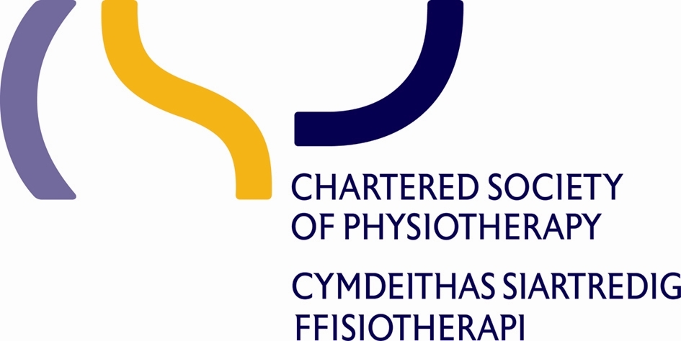
CSP Wales conference 2016

Inspiration, Demonstration, Innovation
Abstract Submission Proforma
We are looking for examples of service improvements, innovations, service evaluation, audits to change practice, and research, to share with your colleagues across Wales.
This submission is to be considered for (please tick one below)

Verbal presentation (max 7 mins)
Poster- conference display
Title:

Author:

Author contact details:

Abstract (300 words):
Background - why is this important?
Aims/Objectives - what was the purpose?
Methods- how/what was done?
Results- what was the outcome?
Conclusions- what difference did/will this make?

To be returned to:
Ruth.emanuel@wales.nhs.uk or
Physiotherapy dept, Singleton Hospital, Swansea, SA2 8QA
Closing date for submissions: Friday 15th April 2016

